**ISM6215**

**Business Database Systems 1**

FOOD DELIVERY INTERMEDIARIES



Haokai Gou

Harsh Wardhan

Jeet Patel

Kirsten Hugh

Sarah Alikhan

Scarlet Wessin

Snehal Jitendra Deshmukh

**Table of Contents**

**Background information 1**

Business application 1

Model 3

Operation 5

**ER Diagram of the Business Application 6**

Heading 1 7

**ER diagram to logical schema Conversion 8**

**MySQL Workbench Relationship Table(s) Design 9**

how to create the database 9

how to modify the database 9

how to query the database 9

**QUERY 1 9**

**QUERY 2 9**

**QUERY 3 10**

# Background information

In a food delivery system, there are typically three parties involved.

1. The customer/ person ordering

2. The delivery agent

3. The restaurant where the order is placed

The person placing an order, first logs into the app to browse through the available restaurant options. They would then choose the restaurant they want to order from, decides on item(s) to order, and then reviews the details of their selection on the checkout page. On the checkout page, they will then set the tip amount, payment method, delivery address, order delivery time, and if there is a promotion they wish to apply to their order. Upon completing the process in the app, the involved restaurant is informed about the order details. Once the payment details are verified, the restaurant processes the order. Simultaneously, a delivery person is matched with the order and receives delivery instructions, picks it up from the restaurant (once the order is ready), and delivers it to the person who placed the order.

3 rectangles with rounded corners each with diffrent colors green, blue, dark blue

## Business application

You can easily change the formatting of selected text in the document text by choosing a look for the selected text from the Quick Styles gallery on the Write tab. On the Insert tab, the galleries include items that are designed to coordinate with the overall look of your document. You can use these galleries to insert tables, headers, footers, lists, cover pages, and other document building blocks. Most controls offer a choice of using the look from the current theme or using a format that you specify directly.



| *“The quote is bold and distinctive. The galleries include items that are designed to coordinate with the overall look of your document.”* |
| --- |

On the Insert tab, the galleries include items that are designed to coordinate with the overall look of your document. You can use these galleries to insert tables, headers, footers, lists, cover pages, and other document building blocks. When you create pictures, charts, or diagrams, they also coordinate with your current document look.

## Model

To change the overall look of your document, choose new Theme elements on the Page Layout tab. To change the looks available in the Quick Style gallery, use the Change Current Quick Style Set command. Both the Themes gallery and the Quick Styles gallery provide reset commands so that you can always restore the look of your document to the original contained in your current template.

You can easily change the formatting of selected text in the document text by choosing a look for the selected text from the Quick Styles gallery on the Write tab. You can also format text directly by using the other controls on the Write tab. Most controls offer a choice of using the look from the current theme or using a format that you specify directly.

Use SmartArt and Charts to display your data. Go to the Insert Tab and you’ll find those two options. Choose which one suits your needs.

One big green circle with a image placeholder with 3 smaller circles with different colors turquoise, geen, blue, connected through lines to the big circle

## Operation

Remember to cite any information you used.

On the References tab, in the Citations & Bibliography group, click Insert Citation for the option to add sources and then place citations in the document.

# ER Diagram of the Business Application

*(including entities, relationships, cardinality constraints, and identifiers, etc. You need to provide some explanations of these settings)*

## Heading 1

You can easily change the formatting of selected text in the document text by choosing a look for the selected text from the Quick Styles gallery on the Write tab. On the Insert tab, the galleries include items that are designed to coordinate with the overall look of your document. You can use these galleries to insert tables, headers, footers, lists, cover pages, and other document building blocks. Most controls offer a choice of using the look from the current theme or using a format that you specify directly.



| *“The quote is bold and distinctive. The galleries include items that are designed to coordinate with the overall look of your document.”* |
| --- |

On the Insert tab, the galleries include items that are designed to coordinate with the overall look of your document. You can use these galleries to insert tables, headers, footers, lists, cover pages, and other document building blocks. When you create pictures, charts, or diagrams, they also coordinate with your current document look.

# ER diagram to logical schema Conversion

*Note: Explain whether the transformed logical schema conforms to the 3rd normal form and if not, split the table/relations so that they conform to the 3rd normal form in the final version.*

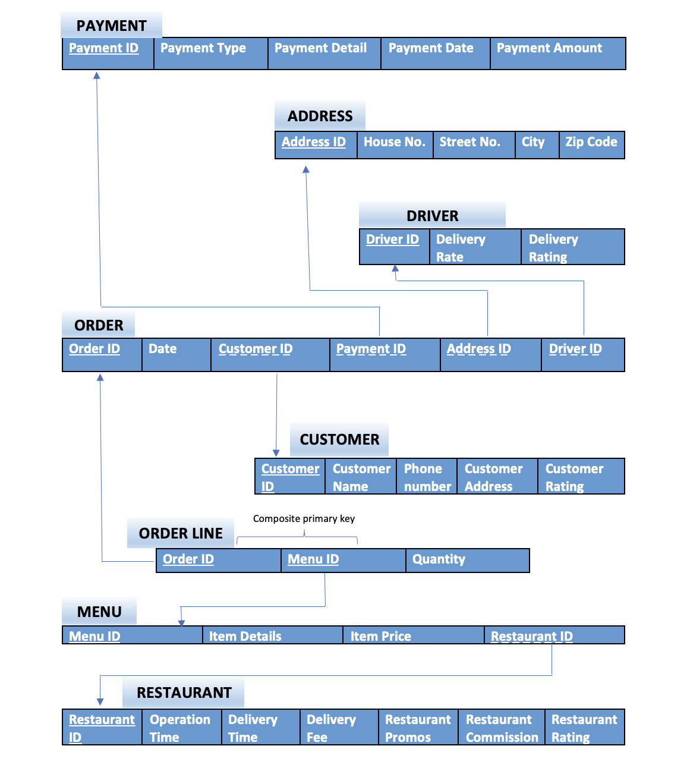

# MySQL Workbench Relationship Table(s) Design

## how to create the database

SQL code

Results in MySQL

## how to modify the database

SQL code

Results in MySQL

## how to query the database

### QUERY 1

SQL code

Results in MySQL

### QUERY 2

SQL code

Explanation of real-world needs for the query

Results in MySQL

### QUERY 3

SQL code

Explanation of real-world needs for the query

Results in MySQL

*Populate your designed relation table(s) in MySQL Workbench and give examples of SQL code snippets on how to create, modify and query the database you collected. You need to explain the specific real-world needs for each of the queries and show results for each operation you conduct in MySQL.*